# If Then Else Worksheet

The flow chart below shows how the points are awarded for a game of football.

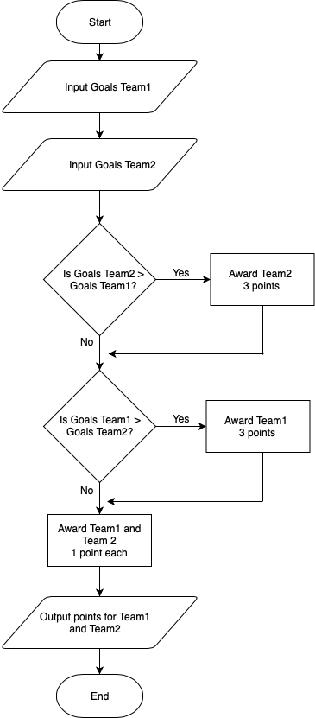

Using the flow chart above, what would be the outputs for the following score lines?

Team 1 – 3 Team 2 – 1

Output ___________

Team1 – 2 Team2 – 2

Output ___________

Team1 – 1 Team2 – 1

Output ____________

# Rock:Paper:Scissors

In a future lesson you are going to create a game of rock:paper:scissors on your micro:bit. Your challenge is to create a flow chart to represent the game.

Each player will choose either rock, paper or scissors. If both players choose the same object, the game will be a draw. Other rules are as follows:

* Rock beats scissors
* Paper beats rock
* Scissors beats paper